BI1I – PROBLEM SET 01 (90 pts)
Winter Term 2026
Released: Friday 01/23/26
Due: Friday 01/30/26 (midnight)

These questions are meant to sharpen your understanding of the content discussed in class. We hope these questions are engaging enough to encourage collaboration and discussion with your fellow classmates; however, you are each expected to submit individual answer sheets, written in your own words. Please cite any outside sources that you use – at times, these questions walk through specific examples that are outside the scope of the lecture slides, so we expect you to consult textbooks and/or published works/reviews. As described in the course policies, you can NOT use ChatGPT or other AI platforms to write your answers, zero tolerance.

Problem 1: Evolutionary Arms Race (12 pts)
a. In class we discussed different immunological threats that organisms face on a single cell level and on a multicellular level, for example: single cells face threats from viruses, which hijack cellular machinery, while on the multicellular level, humans can suffer from autoimmune disease or cancer. Describe in your own words (i) why viruses need to hijack machinery and why this is harmful, and (ii) why autoimmunity and cancer are difficult to combat (think about self vs. non-self discrimination). (4, 4 pts)
Viruses are basically sets of genetic material which are unable to survive independently. Because they lack ribosomes or ways to generate energy, viruses must hijack machinery in some host cell to survive and propagate, effectively stopping the original function of the host machinery and transforming it into a factory for reproduction. It’s harmful because it directly interferes/stops host cell processes and depletes energy and amino acids. In addition the viral reproductive cycle causes lysis which is harmful for a cell and surrounding tissue. The immune system attacks non-self while tolerating self. Because cancer and autoimmunity essentially hijack the self part it’s hard for the body to distinguish between them.

b. Different variants of SARS-CoV-2 have emerged since 2020, as you have probably heard about on the news. As we learned in class, viruses can evolve rapidly to evade host defense mechanisms; however, humans cannot rely on rapid reproduction to evolve quickly like viruses can. How are humans able to compete with these rapidly evolving viruses such as SARS-CoV-2? 4 pts
VDJ recombination randomly assembles gene segments to generate a variety of diverse of B cell receptors and T cell receptors. Cells can also rapidly mutate the genes for their antibodies so that they can bind better to the viruses.

Problem 2: Innate vs. Adaptive Immunity (35 pts)
a. In class, we have discussed how the innate immune system represents evolution on the “million years” time scale, while the adaptive immune system represents evolution on the much smaller weeks/day time scale. Explain (i) what this means and (ii) refer to at least one cell type from the innate system and at least one cell type from the adaptive immune system to illustrate your point. Finally, (iii) address the differing strengths and weaknesses of each system’s defense strategy. (4, 4, 6 pts)

Innate immune system represents evolution on a million years time scale meaning the receptors it uses are encoded in our DNA. They are able to generally filter out pathogens that rarely change and are sort of hard coded at birth. For example, macrophages express TLRs to recognize specific patterns, which are inherited from your parents’ DNA and relatively constant. Meanwhile the adaptive immune system adapts in a shorter term using VDJ recombination. It uses evolutions via clonal selection to create a plethora of unique and fine tuned receptors in days to weeks. An example of this is T cells which are able to recognize specific foreign antigens on other cells and destroy them. Innate is strong because it’s fast and works generally for a variety of antigens while it has limited specificity and memory. Adaptive immunity has much stronger memory but is slow to start the first time.

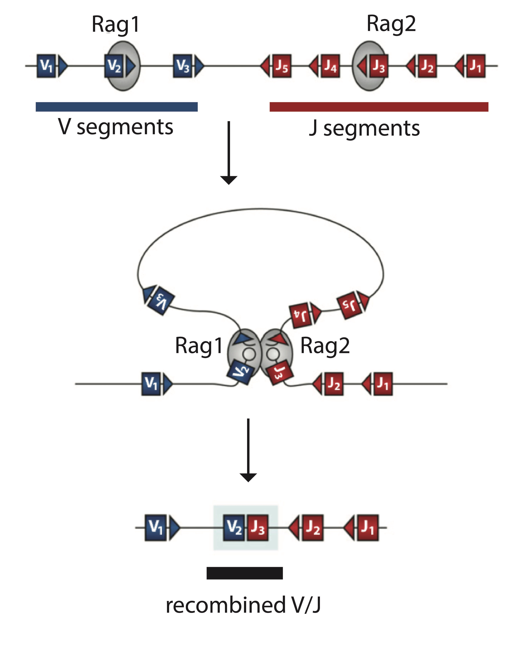
As mentioned in class, though the adaptive immune system is extremely important for defending the body against potential threats, it is not completely necessary for survival. In fact, Rag1^{-/-} mice, which have been genetically modified to “knockout” Rag1 expression, do not have T cells or B cells and can still survive (though they are highly immunocompromised and need to live in sterile conditions). You are interested in understanding how such a mouse can survive without an adaptive immune system, so you want to perform your own Rag1 “knockout” experiments. First though, you are curious about why Rag1^{-/-} mice do not have T cells or B cells. Let’s discuss:

Rag1^{-/-} mice do not have the Rag1 protein, which is a protein that is critically involved in V(D)J recombination: during this process, Rag1 and its partner Rag2 bring together specific V, D and J segments and help perform the double stranded DNA breaks that are needed to create a newly recombined genomic region that encodes a unique VDJ or VJ combination (diagram right).

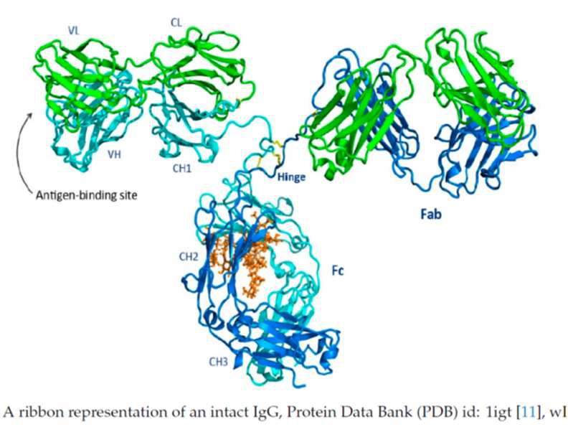
b. Given this information about Rag1, circle the specific area of the immunoglobulin structure below that is impacted by knocking out Rag1 and disrupting V(D)J recombination. 2 pts
Not sure how to edit images in word but I’d circle the V_L and V_H regions.

c. Even though Rag1 only impacts a small area of the immunoglobulin, its impact is big. Explain why disrupting the region circled above would negatively impact B cell activity in the context of the adaptive immune system. 4 pts

The areas I circled make up the antigen binding site; without this, B cells would not be able to recognize and bind to a specific antigen and they may even get destroyed given they need constant signals to survive.

d. What if Rag1 activity was only impaired; for example, what if you only decreased Rag1 activity so that it was functioning at half its normal capacity such that V(D)J recombination was still possible, just not as efficient. Would B cell activity still be impacted? Would the greater adaptive immune response be impacted? (think about problem 1b and the diversity of B cells) 4 pts

Reducing Rag1 efficiency would lower the success rate of VDJ recombination which would results in fewer completely working B cells being produced. Something else important to note is that the power of adaptive immunity comes from having enough uniqueness to recognize any possible antigen. By effectively halving the recombinations there would be holes in the diversity with simply some antigens having no respective B cell. Practically this would allow humans to be less able to compete with rapidly evolving viruses.

Now that you know why Rag1^{-/-} mice do not have a functional adaptive immune system, you are extra excited to start your own knockout experiments and answer your own questions. Let’s next think through the technical aspects of your knockout experiment:

You want to start from scratch and not use the commercial Rag1^{-/-} mice. Looking through the literature, you realize it is common to perform “loss-of-function” knockout experiments in model organisms such as mice. Consequently, there are many strategies for “knocking out” a protein of interest:
- The CRISPR/Cas9 system can be used to target specific sequences and perform double stranded DNA breaks at those sequences, which the cell repairs imperfectly. The resulting genomic region could thus end up with an insertion/deletion that causes the gene to be non-functional.
- short interfering RNA (siRNA): these short pieces of double stranded RNA recruits and guides a greater complex of proteins towards target mRNA and cleaves the target mRNA.
- The Auxin-Inducible Degron (AID) system: target proteins are modified to also express a protein degradation tag such that, when a molecule called auxin is added to the system by the researcher, the degradation tag recruits an enzyme that destroys the original protein

e. Keeping the central dogma in mind (DNA, RNA, protein), what are the particular advantages/disadvantages to the strategies described above? Consequently, what would you choose for your Rag1 knockout? 7 pts
(If you are interested, you can consider different rates and stabilities by browsing this website made by Rob Phillips, Caltech biophysics professor: https://book.bionumbers.org/what-is-faster-transcription-or-translation/)

Method | Advantages | Disadvantages
CRISPR/Cas9 | Alters the genome itself permanently ensuring all daughter cells inherit the change | May accidentally cut similar DNA sequences elsewhere
siRNA | Temporary/reversible so its good for studying short-term effects | Doesn’t have a 100% knockout meaning it requires constant delivery of the RNA; hence impermanent
AID | Degrades the existing protein almost instantly and is reversible | Very complex to set up

If I had to choose one I’d choose CRISPR/Cas9 because it’s permanent, always works, and passes down to daughter cells. Other ones are too ineffective/impractical.

f. Interestingly, in many instances, Rag1 knockout models that are introduced to bacterial infection end up producing a destructive inflammatory response, and in the worst case induce sepsis. This is why in humans, infants who are born with Rag1 deficiency and develop Severe Combined Immunodeficiency (SCID) or “bubble boy disease” must live in extremely sterile conditions. If the innate immune system is still active in these instances, how could bacteria infections still cause such an undesirable inflammatory response? 4 pts

Without the adaptive immune system, the innate system can solely detect and respond to bacteria but not efficiently clear them. This means, when bacteria invades a system, it persists and the innate immune system keeps producing cytokines, which will eventually damage the body. In addition without an adaptive immune system inflammation will be self perpetuating.

Problem 3. Human Papillomaviruses (43 pts)
Human Papillomaviruses (HPVs) are the causative agents of a large number of human malignancies, chief among which is cervical cancer, with over 500,000 reported cases worldwide annually. HPV is a group of common viruses characterized by their small, non-enveloped DNA structure, often causing asymptomatic infections, but sometimes leading to visible symptoms like genital or skin warts (types HPV6, HPV11) or cellular changes that can progress to various cancers (high-risk types like HPV16, HPV18) affecting the cervix, anus, throat, and other areas.

One of the more studied proteins that HPV encodes for is the “oncoprotein” E6. Interestingly, E6 protein binds IRF-3, which is a transcription factor that normally activates cell death if viral components are detected within the cell. E6 binding to IRF-3 blocks IRF-3’s normal activity; thus, HPV uses E6 to evade one of the host’s antiviral defense systems. This prevention of cell death likely contributes to the cancerous phenotype of uncontrollable cell growth.

Consequently, you aim to develop a therapeutic recombinant vaccine that preemptively introduces E6 into the body, preparing it for future infections by facilitating a faster immune response. To do this, you want to take a closer look at the E6 protein itself. Below is a structure of the E6 protein (right) along with the region of IRF-3 that it binds to (PDB ID: 6SJA). The size of this protein complex is 61.13 kDa. The size of E6 is roughly 16 kDa.

The sugar ligand (that you see in IRF3) is present because the IRF3 peptide was expressed as a fusion protein with Maltose-binding protein (MBP). The small IRF3 peptide fragment (residues 187-211) might be prone to misfolding or aggregation when expressed alone in bacteria. Fusing it to MBP helps ensure that the complex remains soluble. E6 has two zinc ions that bind two distinct zinc-binding domains (E6N and E6C) that are essential for its stability and oncogenic function. Each zinc ion is tetrahedrally coordinated by four conserved cysteine residues arranged in two C-x-x-C motifs. One zinc ion is located in the N-terminal domain (E6N), coordinated by cysteines 30, 33, 63, and 66. The second zinc ion is located in the C-terminal domain (E6C), coordinated by cysteines 103, 106, 136, and 139.

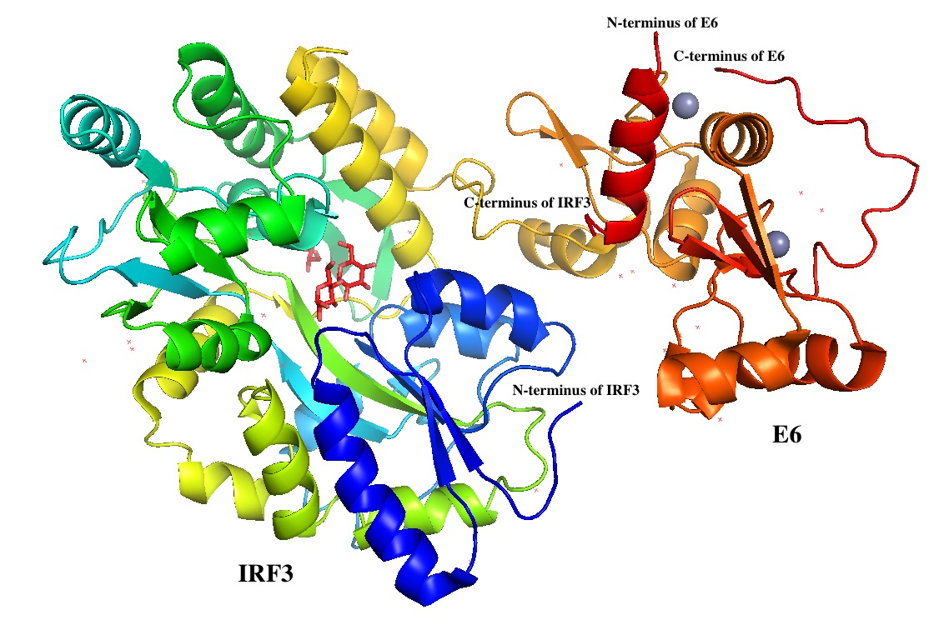

a. What kind of structures does the E6 protein mostly consist of? 1 pts

Mainly alpha helices and some beta regions.

b. Based on your answer in a., what is the importance of having several domains of this protein structure? 3 pts

This allows for stability as each protein can fold into a stable unit. In addition, each protein can provide different binding surfaces.

You want to perform experiments on the E6 protein in vitro, but you need a LOT of the protein to perform your experiments. This is a very common problem in biology research, but luckily there is a well-established protocol for engineering bacteria to produce large amounts of a protein of interest. This process requires you to engineer a circular piece of DNA, a plasmid, encoding for your protein of interest. You can then insert the plasmid into bacteria (transformation), which are naturally able to make proteins encoded by plasmids.

You start the process by engineering your plasmid: you want to insert the nucleic acid sequence encoding the protein, in this case E6, into an established plasmid backbone. You will have to use Polymerase Chain Reaction (PCR) to amplify the E6 sequence. The sequence shown below contains the E6 gene (excluding IRF3).

5'-ccattcggaatgcaccaaa aaagaactgc aatgtttcag gacccacagg agcgacccag aaagttacca
cagttatgca cagagctgca aacaactata catgatataa tattagaatg tgtgtactgc
aagcaacagt tactgcgacg tgaggtatat gactttgctt ttcgggattt atgcatagta
tatagagatg ggaatccata tgctgtatgt gataaatgtt taaagtttta ttctaaaatt
agtgagtata gacattattg ttatagtttg tatggaacaa cattagaaca gcaatacaac
aaaccgttgt gtgatttgtt aattaggtgt attaactgtc aaaagccact gtgtcctgaa
gaaaagcaaa gacatctgga caaaaagcaa agattccata atataagggg tcggtggacc
tcgatgta tgtcttgttg cagatcatca agaacacgta gagaaaccca gctgtaaggtact-3'

Referring to the codon cheat sheet (last page of problem set), you analyze the E6 DNA sequence:

c. Where is the most likely start codon located? Is there only one? Annotate it/them in the sequence shown above. 2 pts
There are two ATGs but the first one is likely the start codon.
d. Where is the stop codon located? Annotate it in the sequence shown above. 2 pts
Annotated in orange.
e. If transcription started at nucleotide c (5 nucleotides upstream of the codon in yellow), and translation started at the codon highlighted in yellow, what would the result of this be on the translation of the E6 protein? 4 pts
5 is not divisible by 3 so the ribosome would read the sequence in a shifted frame. This would result in a completely different amino acid sequence and a nonfunctional protein.

f. If transcription started at nucleotide c (6 nucleotides upstream of the codon in cyan), and translation started at the codon highlighted in cyan, what would the result of this be on the translation of the E6 protein? 4 pts
6 is divisible by 3 so the reading frame is maintained. However the translation would start at a different place than the normal ATG and the resulting protein would likely be missing the first few amino acids which could disrupt folding.
g. Now that you are familiar with the E6 DNA sequence, you want to design primers to correctly amplify the gene that encodes the E6 protein with PCR. Design forward and reverse primers to this end. For reference, primers are normally 18-20 bps in length. 14 pts
A good choice is to amplify from the first ATG through the stop codon.

Forward: 5'- ATG TTT CAG GAC CCA CAG -3'
Reverse: 5'- AGT ACC TTA CAG CTG GGT -3'

h. In addition to creating a therapeutic vaccine, you wonder if there is a way to directly disrupt E6 activity even after HPV integrates its viral DNA into the host genome. Thinking back to question 2e, you remember the CRISPR/Cas9 system, which introduces double stranded DNA breaks that are imperfectly healed in such a way that allows insertions or deletions of nucleotides. What would you want to target with the CRISPR/Cas9 system to disrupt E6 activity? (what sort of mutation would you hope for?) 2 pts
We’d want to target the the beginning of the E6 gene to make a frameshift mutation.

You go ahead in engineering the CRISPR/Cas9 system and want to validate whether it effectively mutated E6. You remember that you can use SDS-PAGE (Sodium Dodecyl Sulfate-Polyacrylamide Gel Electrophoresis) to separate proteins by molecular weight (size) using an electric current that runs through a gel matrix. You recall that you can then identify a specific protein’s identity if you have an appropriate antibody that targets your specific protein of interest. After finding such antibody for the E6 protein called Antibody45 (AB45), you decide to check the protein content of HPV-infected cells that have received your CRISPR/Cas9-based treatment.

i. From Southern, Northern, and Western Blot, which blotting technique will you use to check E6 protein levels? 1 pt
Western Blot

You design a blotting experiment where your positive control (Lane 1) consists of an intact and fully-functional E6 protein, your negative control (Lane 2) contains a random protein (not similar to E6), and your Lane 3 is loaded with the protein content from HPV-infected cells that have received your CRISPR/Cas9-based treatment. Once you run an SDS PAGE with these three conditions, you incubate the membrane with AB45 and a dye-conjugated secondary antibody complementary to AB45 (so that it is visible on the gel).

j. Draw lines on the left gel for the results you would expect to see if your CRISPR/Cas9-based therapy was successful. Draw lines on the left gel for the results you would expect to see if your CRISPR/Cas9-based therapy was unsuccessful. The given lines represent a ladder that labels protein mass in kDa. 10 pts

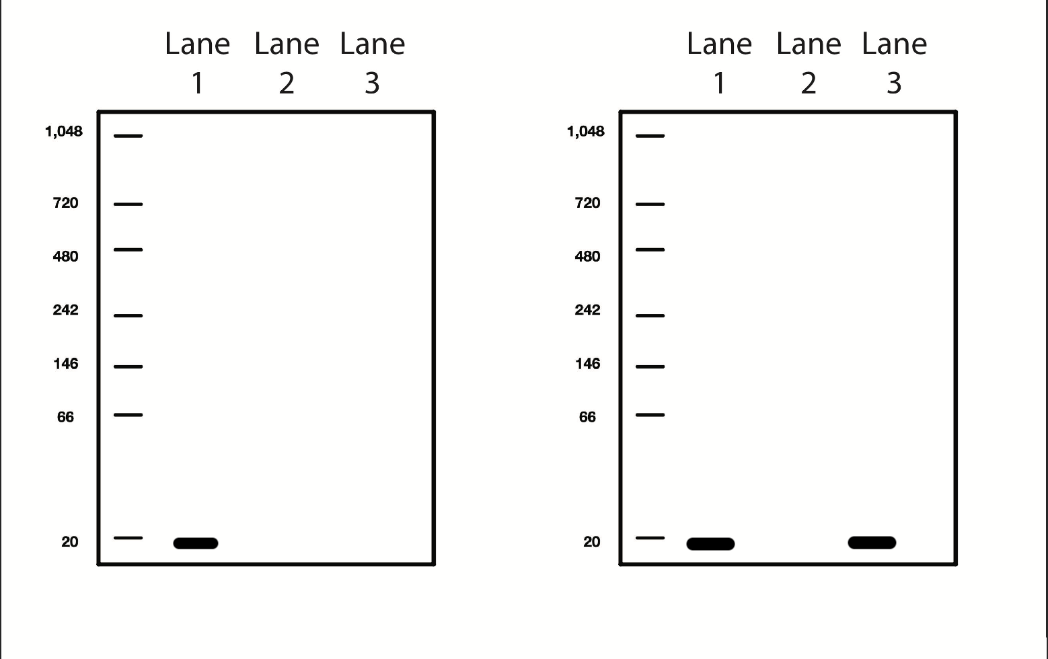

Codon Cheat Sheet:
